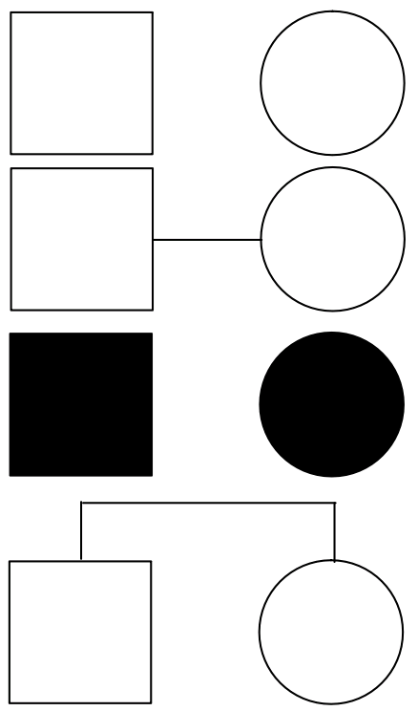

Pedigree Carrier

Sex-linked

